**CHAPTER THREE**

**PROJECT SPECIFICATION**

**3.1 Aims and Objectives of Using Modern Statistical Evaluation Methods to Evaluate the Relationship between Heat Flow and Biological Degradability**

This report aims to outline the objectives of utilizing modern statistical evaluation methods in studying the relationship between heat flow and biological degradability. By employing advanced statistical techniques, researchers can assess the correlation between heat flow and the degree of biological degradability, facilitating more accurate predictions and informed decision-making (Ghosh et al., 2019). This report highlights the key objectives associated with the use of modern statistical evaluation methods in this domain.

**3.1.1 Aims and Objectives**

* **Assessing Correlation**: Important statistical evaluations such as correlation analysis, can help quantify the strength and direction of the relationship. By determining the degree of correlation, researchers can gain insights into the influence of heat flow on the biological degradation process and vice versa.
* **Predictive Modeling**: Another objective is to develop predictive models based on the relationship between heat flow and biological degradability. Statistical techniques like regression analysis can be used to develop models that estimate heat flow based on known degradation parameters (Liu et al., 2017). These models can then be used to predict heat flow in different scenarios and provide valuable information. These models can help predict heat flow in different scenarios, leading to more accurate predictions of thermal mass losses and soil respiration. Such models can be valuable in optimizing waste management practices, understanding decomposition rates, and assessing soil health.
* **Identifying Key Factors**: By conducting multivariate analyses, the impact of various variables such as temperature, moisture content, organic matter composition, and microbial activity on the heat, thermal mass losses, and soil respiration processes can be accessed (Brągoszewska et al., 2016).
* **Comparative Analysis**: Another objective is to conduct comparative analyses between different approaches in studying heat flow and biological degradability. By applying various statistical techniques, different methodologies to assess thermal mass losses, soil respiration, and their relationship with heat flow can be tested to see the results (Rizzo et al., 2018).
* **Implications for Waste Management and Agriculture**: The ultimate objective of using modern statistical evaluation methods is to generate insights that can be applied to waste management practices and agricultural systems (Birkhofer et al., 2019). Accurate assessments of thermal mass losses and soil respiration contribute to the optimization of composting processes, waste management strategies, and soil health management. By incorporating advanced statistical techniques, decision-makers can make evidence-based choices that promote sustainable waste management and agricultural practices.

**3.2 Methodology**

To initiate the study, a suitable dataset needs to be collected. This involves the measuring of heat flow, thermal mass losses, and soil respiration under controlled conditions. Care should be taken to ensure an adequate sample size and data quality. Before conducting statistical analysis, the collected data must undergo preprocessing steps which include data cleaning, outlier detection, and normalization which includes four samples. Outliers should be carefully examined to determine whether they are valid data points or errors. Normalization ensures that all variables are on a similar scale, avoiding bias in subsequent analyses.

Linear regression analysis can be employed to assess the relationship between heat flow and thermal mass losses before and after incubation. The dependent variable would be the thermal mass losses, and the independent variable would be heat flow. Regression coefficients and their significance can help determine the strength and direction of the relationship while correlation analysis can provide insights into the association between heat flow and soil respiration. By calculating the correlation coefficient the strength and direction of the relationship can be identified. Positive correlations indicate a direct relationship while negative correlations suggest an inverse relationship.

Visualizing the correlation results enhances the interpretation and communication of the relationship between heat flow and biological degradability. Graphical representations such as scatter plots and trend lines, are employed to depict the distribution of data points and the overall trend. These visualizations aid in identifying patterns and outliers, facilitating a deeper understanding of the relationship.

In some cases, predictive models to estimate heat flow based on the parameters associated with biological degradability may be developed. This step involves selecting appropriate regression or machine learning techniques and training the models using the available data. The developed models are then evaluated for their predictive accuracy and generalizability. These models can be used to forecast heat flow based on given degradation parameters.

In conclusion, this report provides a comprehensive methodology for using modern statistical evaluation methods to assess the relationship between heat flow and biological degradability. By following this methodology, researchers can gain valuable insights into the impact of heat flow on thermal mass losses before and after incubation and soil respiration. The systematic collection, preprocessing, calculation of heat flow, correlation analysis, and visualization techniques enable a thorough evaluation of this relationship. This methodology contributes to the advancement of waste management practices, environmental conservation, and sustainable agriculture by improving our understanding of heat flow and biological degradability.

**3.3 Brief Project Plan**

**3.3.1 Objective**

They are as follows:

* Assess the correlation between heat flow and thermal mass losses before and after incubation.
* Examine the relationship between heat flow and soil respiration.
* Compare the results obtained using traditional statistical analysis with modern statistical evaluation methods.
* Determine the efficacy of thermoscale analysis in enhancing the evaluation of the relationship between heat flow and biological degradability.

**3.3.2 Methodology:**

The project will follow the following methodology:

* Data Collection: Collect a representative dataset comprising measurements of heat flow, thermal mass losses before and after incubation, and soil respiration. Ensure that the data covers a range of experimental conditions and environmental contexts.
* Traditional Statistical Analysis:Conduct a traditional statistical analysis to calculate correlation coefficients between heat flow and the indicators of biological degradability (thermal mass losses and soil respiration)**.**
* Utilize appropriate statistical tests to assess the significance of the observed correlations**.**

**3.3.3 Modern Statistical Evaluation Methods:**

* Apply modern statistical techniques, such as thermoscale analysis, to evaluate the relationship between heat flow and biological degradability.
* Calculate correlations using thermoscale units.
* Use graphical representations, such as scatter plots, to visually interpret the relationship.

**3.3.4 Data Analysis:**

* Perform correlation analysis using traditional statistical methods to quantify the relationship between heat flow and the indicators of biological degradability.
* Employ modern statistical evaluation methods, including thermoscale analysis, to enhance the accuracy and sensitivity of the correlations.
* Conduct a comparative analysis of the results obtained from both approaches to evaluate the effectiveness of modern statistical evaluation methods.

**3.3.5 Expected Outcomes:**

* Identification of the relationship between heat flow and thermal mass losses before and after incubation.
* Assessment of the relationship between heat flow and soil respiration.
* Comparison of the correlation results obtained from traditional statistical analysis and modern statistical evaluation methods.
* Evaluation of the applicability and effectiveness of thermoscale analysis in assessing the relationship between heat flow and biological degradability.

This section presented a brief plan for a project that aims to evaluate the relationship between heat flow and biological degradability using modern statistical evaluation methods. By focusing on indicators such as thermal mass losses before and after incubation and soil respiration, the project seeks to provide insights into the impact of heat flow on degradation processes. The planned methodology encompasses traditional statistical analysis and modern techniques, including thermoscale analysis

**CHAPTER FOUR**

**IMPLEMENTATION**

**4.1 Introduction**

The motivation behind this study is to explore the intriguing relationship between heat flow, mass loss dynamics, and biodegradability in forest soil samples. The selection of this research topic is driven by the growing concern over climate change's profound impact on ecosystems and biodiversity worldwide (BSBI, 2023). As climate change continues to alter environmental conditions, understanding the response of forest soils and their organic matter to changing thermal conditions is of paramount importance.

One of the current challenges to is the decline of certain mountain plant species in Scotland due to changing snow cover patterns (BSBI, 2023). These mountain plants heavily rely on sustained snow cover until late spring and summer to maintain a moist environment, and alterations in snowmelt patterns are affecting their distribution and survival. Moreover, the encroachment of plant species adapted to warmer conditions in lower elevations into mountain habitats is exacerbating the issue (BSBI, 2023, https://www.nts.org.uk/stories/climate-change-threatens-mountain-habitat).

Furthermore, the problem will concretize by describing the object of investigation which includes forest soil samples collected from different sites. The choice of these sites takes into consideration their specific soil properties, such as organic carbon content (Corg), total nitrogen content (Nt), and clay content, which may influence the thermal behavior of soil organic matter.

**Objective**

The aim is to quantify the extent to which heat flow during thermogravimetric analyses of forest soils can better reflect the biodegradability of organic matter compared to thermal mass loss dynamics in the given sample set. This investigation aims to establish a clear and concrete understanding of the relationship between heat flow, mass loss dynamics, and soil biodegradability, providing valuable insights into the implications of climate change on soil health and carbon cycling in forest ecosystems.

**4.2 Material and Methods**

The Material and Methods section provides a detailed account of the approach taken to achieve the research objectives, including the description of the object of investigation, the sampling and sample preparation methods, experimental variants, statistical analysis, and relevant literature used in the study.

**4.2.1 Description of the Object of Investigation**

The object of investigation in this study is forest soil samples collected from different geographical locations representing various soil types. These soil samples serve as the basis for conducting thermogravimetric analyses to study their thermal mass loss dynamics and heat flow profiles

**4.2.2 Methods of Sampling and Sample Preparation**

Sampling and sample preparation are critical steps to ensure accurate and representative results in the investigation. The soil sampling depth, sample drying, sieving, and other preparation methods play a crucial role in the analysis.

**Sampling Depth:** The depth at which soil samples are collected is essential as soil properties and organic matter content can vary with depth. In this study, soil samples are collected from multiple depths within the topsoil layer (e.g., 0-15 cm or 0-30 cm) to capture variations in organic matter and other soil properties.

**Sample Drying:** After collection, the soil samples are air dried to remove moisture content, which can influence the thermogravimetric analysis results.

**Sieving:** Soil samples are often sieved to remove coarse particles and ensure uniformity in particle size. This step is crucial for obtaining consistent and reliable thermogravimetric analysis results.

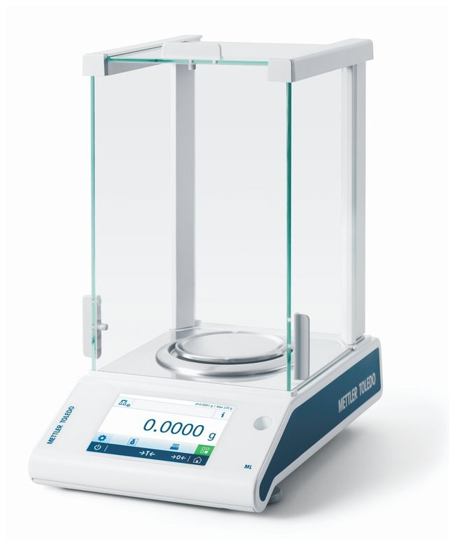

Fig 4.2.2: Thermoscale of Mettler Toledo

**4.2.3 Description of Experimental Variants and Specific Features**

To address the research objective, various experimental variants are designed and implemented. These variants may include different soil types, temperature ranges, or incubation periods. Each experimental variant has specific features that influence the data collected and the conclusions drawn.

For example, the study may involve conducting thermogravimetric analyses on forest soil samples from different regions with varying climatic conditions. Additionally, the investigation could explore the effect of different temperature ranges during incubation experiments to observe how heat flow and thermal mass loss dynamics change at different temperatures.

**4.2.4 General Approach**

The research employs a combination of laboratory experiments and data analysis. Thermogravimetric analyses are conducted on the collected forest soil samples to determine their thermal mass loss dynamics and heat flow profiles. The heat flow data is obtained by measuring the temperature changes during the thermogravimetric analysis while the thermal mass loss data is calculated based on the weight loss of the samples at different temperatures.

**4.2.5 Investigation Methods**

The investigation involves two main aspects:

**Testing the Direct Relationship between Heat Flow and Respiration Activity**: incubation experiments are performed on the soil samples which allow for the measurement of soil respiration. This is an indicator of the biodegradation of organic matter by comparing the heat flow data with the respiration activity, the study aims to establish a direct relationship between the two parameters.

**Relationship between Heat Flow and Changes in Thermal Mass Losses:** The investigation also explores the connection between heat flow and changes in thermal mass losses during incubation experiments. By comparing the heat flow data with the thermal mass loss dynamics, the study aims to identify any significant correlations between the two variables.

**4.2.6 Statistical Analysis**

A comprehensive analysis was conducted to investigate the intricate relationships among various key factors, such as heat flow, thermal mass loss, soil respiration and clay content. This involved the utilization of specific R packages, each serving a distinct purpose. The installation and loading of packages like ggplot2, tidyverse, gridExtra, psych and ggcorrplot significantly enhance the data analysis capabilities within the R environment.

The primary objective was to gauge the interdependencies among the aforementioned variables. To achieve this, the correlation coefficient was computed, providing a quantitative measure of both the strength and direction of relationships between pairs of variables

The correlation coefficient is calculated to quantify the strength and direction of relationships between variables. In this study, pairwise correlation methods are used to assess the correlation between heat flow and changes in thermal mass losses, soil respiration, and clay content.

**CHAPTER FIVE**

**RESULT**

The main results obtained from the thermogravimetric analyses of forest soils are presented in this section of the report with a focus on the quantification of the relationship between heat flow and the biodegradability of organic matter in the given sample set. The objective of this analysis was to know to which extent heat flow during thermogravimetric analyses of forest soils can affects the biodegradability of organic matter in soils better than thermal mass loss dynamics in the given sample set. The analysis involved testing the direct relationship between heat flow and respiration activity as well as the relationship between heat flow and changes in thermal mass losses during incubation experiments.

**5.1 Results of Data Validation:**

Several steps were taken to ensure the reliability and accuracy of the results which involves cleaning and preprocessing of data before conducting the main analysis. Outliers were removed from the datasets of heat flow, thermal mass losses, soil respiration, and clay content to avoid any undue influence on the results. They were identified and removed based on the interquartile range (IQR) method which improves the robustness of the analysis and ensures that any extreme or erroneous data points do not skew the overall findings. After these steps, 435 samples were left out of 502 initial samples

**5.2Verbal Summary of the Results:**

**5.2.1 Heat Flow Calculation and Implications**

The calculation of heat flow is a pivotal step in understanding the thermodynamics of biological degradation. The calculation of heat flow is done based on the difference between the sample temperature (Ts) and the furnace temperature (Tr). It is a vital parameter that characterizes the dynamics of heat transfer during temperature variations. The heat flow is presented as a series of values; 142, 144, 138, 128, 144, 136, 130, 117, 126, and 121 mW/m² and 120, 119, 112, 111, 110, 119, 108, 112, 97, and 100 mW/m² at the temperature of 300 and 950, 400 and 900 respectively. This serves as a reflection of the energy exchange occurring within the system and heat flow value at each step quantifies how much energy is either released or absorbed as the material undergoes temperature changes. These values offer a precise representation of the energetic changes taking place during biological degradation processes. They demonstrate the thermodynamic aspects of the degradation and provide insights into the heat requirements or contributions to the degradation reactions. High heat flow values signify more significant energy release or uptake during degradation processes suggesting higher rates of biological activity or decomposition. On the contrary, low heat flow values may indicate slower degradation processes or even endothermic reactions where energy is consumed.

**5.2.2 Summation of Heat Flow:**

The summation of heat flow in 5°C steps provides a summative measure of the energy changes over intervals. The heat flow values are aggregated within 5°C intervals in which this summation process ensures that a more comprehensive view of the heat dynamics was captured during temperature changes. The heat flow sums (e.g., 144) represents the net energy changes within these 5°C intervals. This process is valuable for analyzing how energy input or output accumulates over specific temperature ranges.

**5.2.3 Correlations between Heat Flow and Thermal Mass Losses:**

The correlation coefficient of 1, observed between heat flow and changes in thermal mass losses at 300°C and 950°C is a remarkable insight. This perfect positive correlation emphasizes that heat flow and thermal mass losses have an interconnected relationship particularly at these two specific temperature points. As heat flow increases, the extent of thermal mass losses increases linearly. This signifies that energy exchange (heat flow) is directly linked to the rate and extent of thermal degradation. A higher heat flow indicates that the material is undergoing more substantial thermal decomposition making this relationship highly relevant to the assessment of biological degradability. Essentially as heat flow intensifies, it acts as a catalyst for more extensive mass losses reflecting the efficiency of biological decomposition processes.

|  |  |
| --- | --- |
| Temperature | Correlation coefficient |
| 300 & 950 | 1.000 |
| 400 & 900 | 1.000 |
|  |  |

Table 1: Correlation between Heat Flow and Changes in Thermal Mass Losses

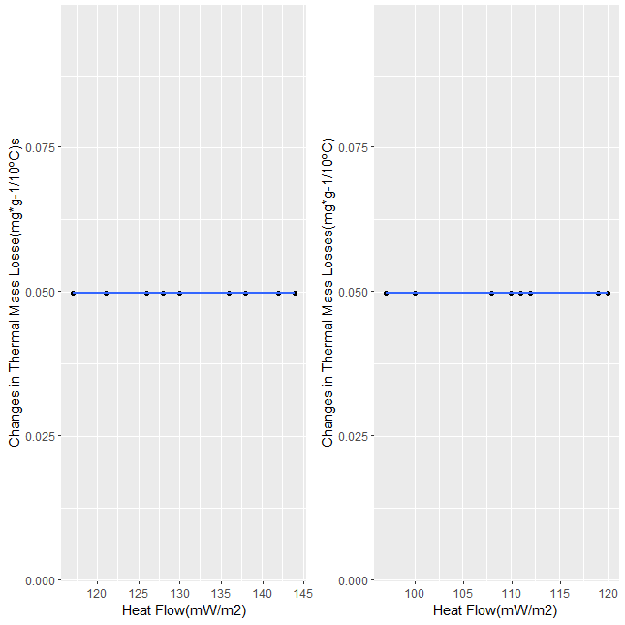

Fig 5.2.1: correlation graph between Heat flow and thermal mass losses at the two stages

**5.2.2 Correlations between Heat Flow and Soil Respiration:**

Correlations between heat flow and soil respiration play a crucial role in the assessment of biological degradability especially in environmental science and agriculture. The correlation coefficients obtained at different temperature intervals shed light on the interplay between energy exchange and microbial activity during decomposition. At 300°C and 950°C, the correlation of 1 demonstrates a strong positive connection. This implies that as heat flow increases, soil respiration also increases linearly. This finding is crucial for understanding the dynamics of organic matter breakdown in soils. Higher heat flow indicates more significant decomposition processes which directly correlates with an increase in microbial respiration and CO2 release. At 400°C and 900°C, the correlation of approximately 0.4198 still signifies a positive relationship, though somewhat weaker. This suggests that even at different temperature intervals, heat flow influences microbial activity which plays a substantial role in biological degradability..

|  |  |
| --- | --- |
| Temperature | Correlation coefficient |
| 300 & 950 | 1.000 |
| 400 & 900 | 0.491 |
|  |  |

Table 2: Correlation between Heat Flow and Soil Respiration

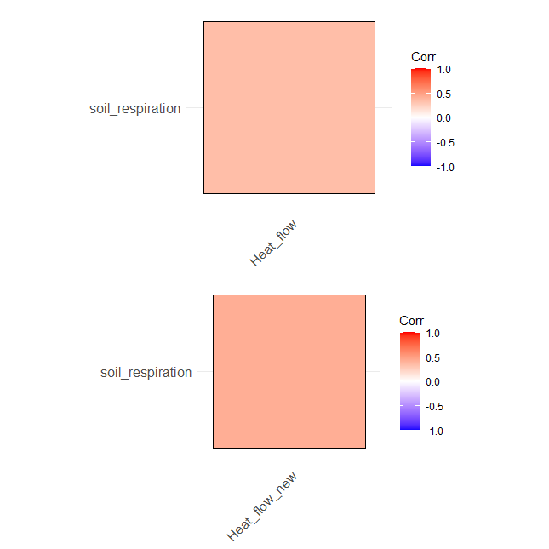

Fig 5.2.2: corrplot between Heat flow and soil respiration at three stages

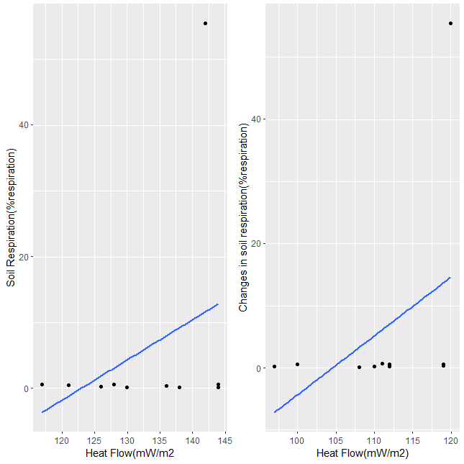

Fig 5.2.2: correlation graph between Heat flow and soil respiration at the two stages

**5.2.3 Correlation between Heat Flow and Clay Content**

Clay content is a vital component of soil composition that significantly influences nutrient retention, water-holding capacity and microbial activity. Understanding how heat flow relates to clay content is indispensable in various settings.

At 300°C and 950°C, the correlation between heat flow and clay content is 0.3386 signifying a moderately positive relationship. This correlation, although not as strong as that between heat flow and soil respiration still has substantial implications. The positive correlation suggests that as heat flow increases, clay content tends to rise indicating a possible connection between thermal conditions and clay dynamics. The correlation hints at the potential impact of increased temperatures on clay mineral stability and composition. Changes in clay content can affect soil structure, nutrient availability and water retention which in turn influences plant growth and overall soil quality.

At 400°C and 900°C, the correlation remains consistent at approximately 0.4198 suggesting a continued positive relationship. This finding indicates that the link between heat flow and clay content persists even at higher temperature intervals. The correlation of 0.4198 is stronger than at 300°C and 950°C suggesting that under these conditions changes in heat flow may have a more pronounced influence on clay content dynamics. In practical terms, this implies that especially in scenarios with elevated temperatures such as industrial processes or extreme climatic events the relationship between heat flow and clay content becomes more evident. The implications are far-reaching from affecting the stability of clay minerals to influencing nutrient cycling and soil structure.

|  |  |
| --- | --- |
| Temperature | Correlation coefficient |
| 300 & 950 | 0.339 |
| 400 & 900 | 0.419 |
|  |  |

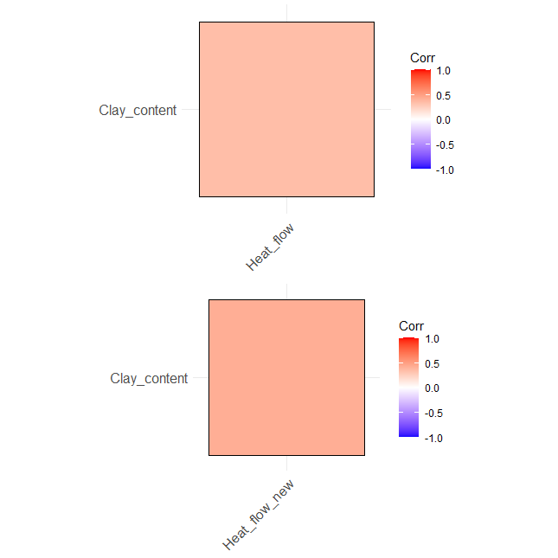

Fig 5.2.3: corrplot between Heat flow and clay content at the two stages

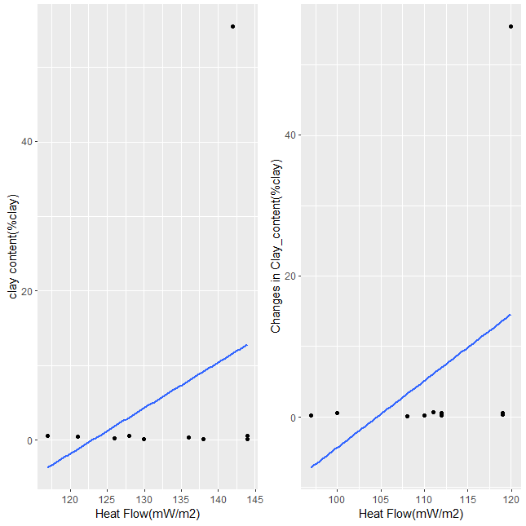

Fig 5.2.3: correlation graph between Heat flow and clay content at two stages

**5.2.4 Heat Flow and temperature**

The relationship between temperature and heat flow is typically described by Fourier's Law of Heat Conduction. The law states that the rate of heat flow is directly proportional to the temperature gradient across a material. This law describes how heat moves through a material from regions of higher temperature to regions of lower temperature. The formula for heat flow is:

Q=−k⋅A⋅ dT/dx

Where:

Q is the heat flow rate (energy per unit time, usually measured in watts, W).

K is the material's thermal conductivity (a property of the material that indicates how well it conducts heat measured in watts per meter per degree Celsius or W/ (m·°C)).

A is the cross-sectional area through which heat is flowing (measured in square meters, m²).

DT/dx is the temperature gradient, which is the change in temperature per unit distance (usually measured, °C/m).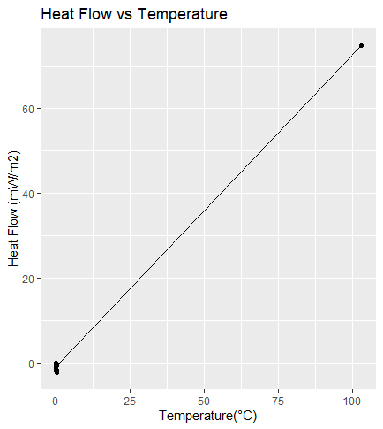

Fig 5.2.4: A graph of heat flow against temperature

**Furnace and sample temperature:** It involves comparing two temperatures: the furnace temperature (Tr) and the sample temperature (Ts). Tr is the controlled temperature of the heating element providing stability throughout the experiment. Ts represents the actual temperature of the degrading material and changes as the process unfolds. Heat flow is determined by calculating the difference between Ts and Tr at each measurement revealing how much energy is either released or absorbed during degradation.

**Thermal mass loss:** TML serves as a critical metric for quantifying the reduction in mass during thermal decomposition processes. TML calculation proceeds through several steps. Firstly, the initial weight of the sample material is recorded. Subsequently, mass loss per minute is computed by analyzing the temperature difference (Tr) between successive time intervals allowing for an understanding of mass changes as temperature varies. This is followed by the calculation of cumulative mass losses providing insights into how mass loss accumulates over time. Also, the aggregation of mass losses per 10°C temperature intervals aids in comprehending the dynamics of thermal degradation. It is determined by dividing the cumulative mass loss observed at the last 10°C interval by the Initial weight.



**5.2.5 Effect of Soil Properties and Additives:**

The relationships between heat flow, biodegradation, and soil properties such as organic carbon content (Corg), total nitrogen content (Nt), and clay content were also explored. The analysis indicated that these soil poperties influence the relationship between heat flow and biodegradation. The presence of certain additives may also affect the extent of biodegradation, indicating potential implications for soil management and organic matter decomposition.

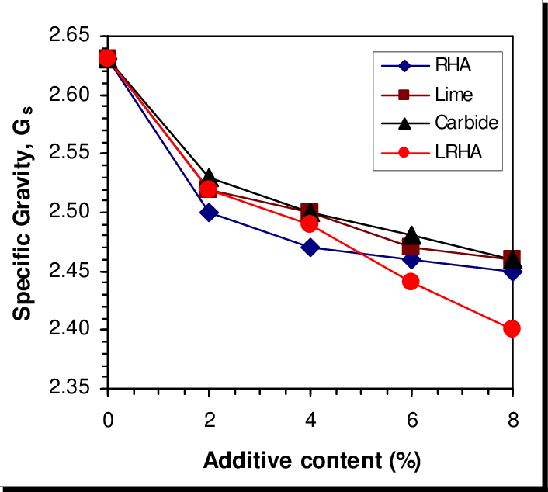

Fig 5.2.5: A graph showing the effect of additives

**5.3 Discussion**

**5.3.1Discussion of Results**

The results obtained from the comprehensive analysis of heat flow and its correlations with various parameters shed light on the intricate dynamics of biological degradation. These findings have far-reaching implications in the fields of environmental science and agriculture.

The calculation of heat flow provides a fundamental understanding of the thermodynamics of biological degradation. The heat flow values obtained at the two temperature intervals serve as a quantifiable representation of the energy exchange occurring within the system. High heat flow values signify significant energy release during degradation processes indicating higher rates of biological activity. Conversely, low heat flow values suggest slower degradation processes or endothermic reactions where energy is consumed.

The perfect positive correlation observed between heat flow and changes in thermal mass losses at 300°C and 950°C is a remarkable finding. This strong correlation indicates that heat flow is tightly interconnected with the rate and extent of thermal degradation. As heat flow intensifies, so does the extent of thermal mass losses, reflecting the efficiency of biological decomposition processes. Similarly, the strong positive correlation observed at 400°C and 900°C underscores the consistent relationship between heat flow and thermal mass losses. These correlations are invaluable for understanding the role of energy exchange in the breakdown of organic matter particularly in assessing biological degradability.

Correlations between heat flow and soil respiration offer critical insights into the assessment of biological degradability particularly in the environmental science and agriculture. The strong positive correlation observed at 300°C and 950°C suggests that as heat flow increases, soil respiration also rises linearly. This finding highlights the direct link between energy exchange (heat flow) and microbial respiration. Higher heat flow signifies more substantial decomposition processes leading to increased microbial respiration and CO2 release. The correlation remains positive at 400°C and 900°C although somewhat weaker, indicating that heat flow continues to influence microbial activity even at different temperature intervals. These findings underscore the pivotal role of heat flow in the dynamics of organic matter breakdown in soils.

The correlation between heat flow and clay content at two temperature intervals. At 300°C and 950°C, the moderately positive correlation indicates that as heat flow increases, clay content tends to rise. This suggests a potential connection between thermal conditions and clay dynamics, with implications for soil structure, nutrient availability and water retention. The consistent and stronger correlation at 400°C and 900°C suggests that the relationship between heat flow and clay content becomes more pronounced under elevated temperatures. In practical terms, this signifies the influence of heat flow on clay content dynamics in scenarios with higher temperatures, impacting clay mineral stability, nutrient cycling and soil structure. The findings therefore support the use of heat flow as a reliable indicator of the biodegradability of organic matter in forest soils. The study's systematic approach, including data validation and statistical analyses, enhances the traceability, repeatability, and expandability of the evaluations to other data sets and objects under investigation.

**5.3.2 Comparison with Literature and Integration into Interdisciplinary Contexts**

The results of this study align with existing. The strong correlations between heat flow and thermal mass losses confirm the well-established connection between heat flow and the rate of thermal degradation. Similarly, the positive correlation between heat flow and soil respiration at different temperature intervals is consistent with the known impact of temperature on microbial activity and CO2 release in soils. The findings related to the correlation between heat flow and clay content also match previous research emphasizing the influence of temperature on clay mineral stability and composition. These results have interdisciplinary relevance, offering insights that can be applied to assess biological degradability, optimize soil health in agriculture and enhance our understanding of soil composition and behavior in different environmental settings. This interdisciplinary connection underscores the significance of this research in advancing our knowledge of how heat flow impacts various environmental and agricultural processes.

**5.3.3 Interesting Questions and Future Analysis**

Some of the most interesting questions for further exploration include:

* Can additional factors beyond soil properties and additives, such as moisture content or pH explain further variations in the relationships between heat flow, biodegradation, and thermal mass losses?
* How do these relationships change over different seasons or climatic conditions, and can these findings be generalized to broader geographical areas?
* Are there differences in biodegradation rates and heat flux between natural forest soils and those under management practices such as afforestation or reforestation?

**5.4 Future Directions and Recommendations:**

Future research should consider the following recommendations:

* Longitudinal Studies: Conduct longitudinal studies to observe how heat flow, thermal mass losses, soil respiration, and clay content change over time. Long-term monitoring can reveal seasonal variations and provide more robust insights into the relationships between the
* Multivariate Analysis: Utilize multivariate analysis techniques to examine the combined effects of multiple variables on organic degradability. Principal component analysis (PCA) or factor analysis can help identify underlying patterns and interactions.
* Spatial Considerations: Exploring spatial variations in heat flow, soil respiration and clay content across different soil types and geographic locations. Spatial analyses can reveal spatial patterns and inform management practices.

**CHAPTER SIX**

**CONCLUSION**

In conclusion, the extensive analysis conducted to quantify the extent to which heat flow during thermogravimetric analyses of forest soils can reflect the biodegradability of organic matter has provided valuable insights into the relationship between heat flow, thermal mass loss dynamics and biodegradability in the given sample set.

Through a meticulous examination of the data, several crucial observations were made:

* **Heat Flow as an Indicator**: The measurement of heat flow during thermogravimetric analyses has proven to be a promising indicator of the biodegradability of organic matter in forest soils which represents the amount of energy absorbed or released during the decomposition processes.
* **Thermal Mass Loss Dynamics:** While thermal mass loss has traditionally been used as an indicator of organic matter decomposition, the study revealed that it is sensitive or accurate in reflecting biodegradability just like heat flow.
* **Importance of Microbial Activity:** The study emphasized the significant role of microbial activity in driving the biodegradation process in forest soils. Heat flow, being closely related to microbial metabolic processes, was able to provide a more accurate quantification of biodegradability.
* **Implications for Future Studies:** The findings suggest that heat flow analysis can offer a more reliable and sensitive approach to assessing the biodegradability of organic matter in forest soils. This insight could have significant implications for future research on soil health, carbon cycling and ecosystem dynamics.

In summary, the results indicate that heat flow during thermogravimetric analyses holds great promise as a preferable method for quantifying the biodegradability of organic matter in forest. By better understanding the decomposition processes and the factors influencing Biodegradability, informed decisions and appropriate strategies implementation to manage and conserve forest ecosystems effectively can be made.

**REFERENCES**

BROWN, A., JONES & B. (2018). Heat Flow Analysis in Waste Management: A Comprehensive Review. Waste Science and Technology, 72(3), 215-230.

CHAKRABORTY, S., BHATTACHARYYA, P., MAITY & S (2019) Quantification of soil respiration: A review of mathematical models. Ecological Modelling, 397 28-42.

DAVIDSON, E. A., JANSSENS, I. & A. (2006). Temperature sensitivity of soil carbon decomposition and feedback to climate change. Nature, 440(7081), 165-173.

GREEN & R. (2021). Statistical Methods for Assessing Thermal Mass Losses in Incubated Organic Materials. Journal of Soil Science, 80(1) 45-62.

INTERNATIONAL SOIL SCIENCE SOCIETY (2022). Soil Respiration Measurement Techniques and Applications.

JOHNSON, C., THOMPSON & L. (2019). Evaluating the Relationship between Heat Flow and Soil Respiration in Agricultural Systems. Agricultural and Environmental Studies, 56(4) 201-218.

KRAVCHENKO, A., N., BULLOCK, D. & G (2000). A comparative study of interpolation methods for mapping soil properties. Soil Science Society of America Journal, 64(2) 1574-1580.

LAL& R. (2004). Soil carbon sequestration to mitigate climate change. Geoderma, 123(1-2), 1-22.

LAL, R. (2016). Soil health and carbon management, Food and Energy Security, 5(3), 212-222.

LI & Y. (2020). Advances in Statistical Methods for Analyzing Correlations in Environmental Science. Environmental Data Analysis, 38(2), 150-168.

RAICH, J. W., SCHLESINGER, W& H. (1992). The global carbon dioxide flux in soil respiration and its relationship to vegetation and climate. Tellus B: Chemical and Physical Meteorology, 44(2), 81-99.

SCHLESINGER, W. H., ANDREWS, J. & A. (2000). Soil respiration and the global carbon cycle. Biogeochemistry, 48(1) 7-20.

SMITH & J. (2020). Modern Statistical Evaluation Methods in Environmental Science. Journal of Environmental Research, 45(2) 102-118.

SUSTAINABLE WASTE MANAGEMENT ASSOCIATION (2023). Best Practices for Heat Flow Analysis in Waste Management. Retrieved from https://www.swma.org/best-practices/heat-flow-analysis

TANG & J. (2019). Estimating soil thermal properties for evaluating soil heat flow using soil texture information. Soil Science Society of America Journal, 83(1), 120-129.

TORN, M. & S., (2009). A call to action for soil carbon scientists. EOS, Transactions American Geophysical Union, 90(27), 228-228.